DMDD Assignment #2

**Conceptual Design:**

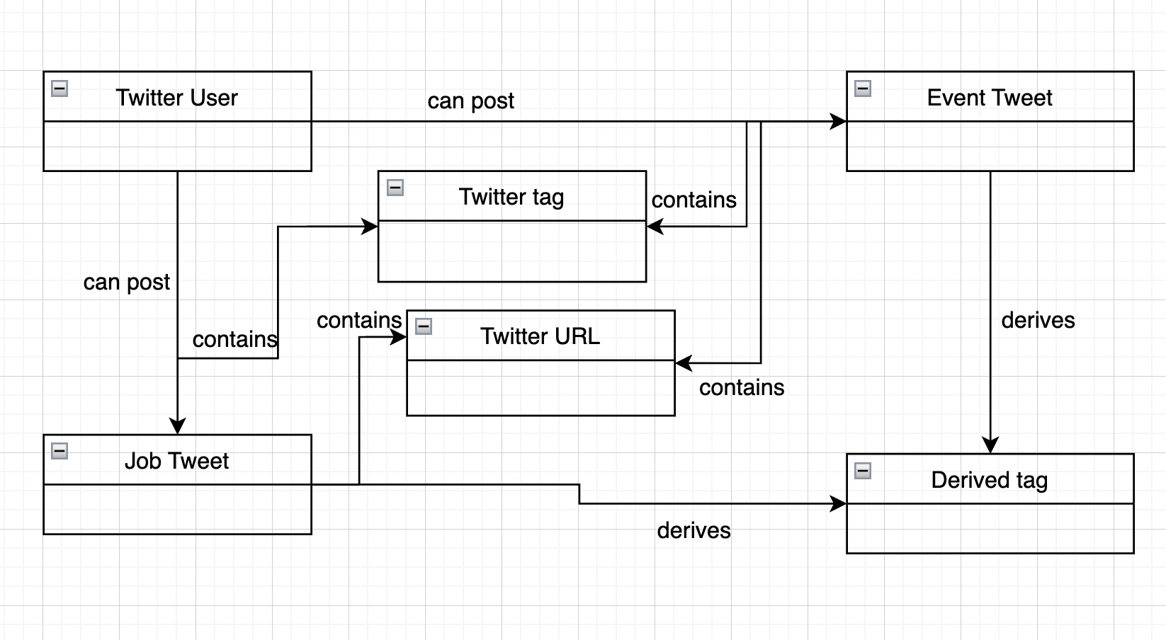

**Physical Model** -

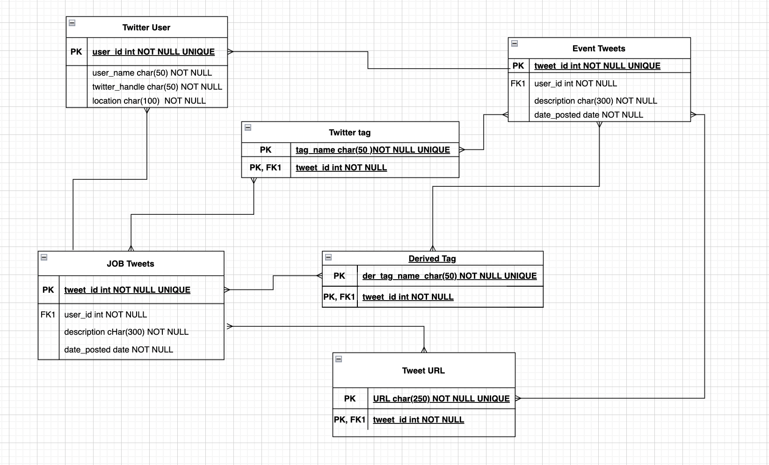

**SQL Statements for Conceptual Model:**

* **Twitter User Table:**

CREATE TABLE `twitter_user` (

`user_id` smallint(10) NOT NULL,

`user_name` varchar(50) NOT NULL,

`twitter_handle` varchar(50) NOT NULL,

`location` char(50),

PRIMARY KEY (`user_id`)

) ENGINE=InnoDB DEFAULT CHARSET=utf8mb4 COLLATE=utf8mb4_0900_ai_ci;

* **Job Tweets Table:**

CREATE TABLE `job_tweets` (

`tweet_id` smallint(10) NOT NULL UNIQUE,

`description` varchar(250) NOT NULL,

`date_posted` date,

PRIMARY KEY (`tweet_id`)

) ENGINE=InnoDB DEFAULT CHARSET=utf8mb4 COLLATE=utf8mb4_0900_ai_ci;

* **Event Tweets Table:**

CREATE TABLE `event_tweets` (

`tweet_id` smallint(10) NOT NULL,

`description` varchar(250) NOT NULL,

`date_posted` date,

PRIMARY KEY (`tweet_id`)

) ENGINE=InnoDB DEFAULT CHARSET=utf8mb4 COLLATE=utf8mb4_0900_ai_ci;

* Twitter tag Table:

CREATE TABLE `twitter_tag` (

`tag_name` varchar(50) NOT NULL,

PRIMARY KEY (`tag_name`)

) ENGINE=InnoDB DEFAULT CHARSET=utf8mb4 COLLATE=utf8mb4_0900_ai_ci;

Twitter URL Table:

CREATE TABLE `tweet_url` (

`url` varchar(250) NOT NULL UNIQUE,

PRIMARY KEY (`url`)

) ENGINE=InnoDB DEFAULT CHARSET=utf8mb4 COLLATE=utf8mb4_0900_ai_ci;

**Derived Tag Table:**

CREATE TABLE `derived_tag` (

`der_tag_name` varchar(50) NOT NULL,

PRIMARY KEY (`der_tag_name`)

) ENGINE=InnoDB DEFAULT CHARSET=utf8mb4 COLLATE=utf8mb4_0900_ai_ci;

ALTER TABLE `derived_tag` ADD `tweet_id` BIGINT(10) NOT NULL PRIMARY KEY;

ALTER TABLE `derived_tag` ADD CONSTRAINT `tweets_fk1` FOREIGN KEY (`tweet_id`) REFERENCES `job_tweets`(tweet_id);

**SQL Statements and Relational Algebra Expressions:**

1. What user posted this job tweet?

**SQL:**

SELECT name

FROM twitter_user

WHERE twitter_user.user_id = (SELECT user_id

FROM job_tweets

WHERE job_tweets.tweet_id = 1589411884968644615);

**Relational Algebra**:

πname  
 σtwitter_user . user_id =  ( πuser_id  
 σjob_tweets . tweet_id = 1589411884968644615 job_tweets )

twitter_user

1. What user posted a tweet about the event?

**SQL:**

SELECT name

FROM twitter_user

WHERE twitter_user.user_id = (SELECT user_id

FROM event_tweets

WHERE event_tweets.tweet_id = 1589411884968644615);

**Relational Algebra**:

πname  
 σtwitter_user . user_id =  ( πuser_id  
 σjob_tweets . tweet_id = 1589411884968644615 event_tweets )

twitter_user

1. When did the user post this tweet about the job?

**SQL:**

SELECT date_posted

FROM job_tweets

WHERE job_tweets.tweet_id = 1589411884968644615;

**Relational Algebra:**

πdate_posted  
 σjob_tweets . tweet_id = 1589411884968644615job_tweets

1. When did the user post this tweet about the event?

**SQL:**

SELECT date_posted

FROM event_tweets

WHERE event_tweets.tweet_id = 1589528329060700160;

**Relational Algebra:**

πdate_posted  
 σevent_tweets . tweet_id = 1589528329060700160event_tweets

1. What keywords/ hashtags are popular?

**SQL:**

SELECT tag_name

FROM twitter_tag

GROUP BY tag_name

ORDER BY COUNT(*) DESC LIMIT 5;

**Relational Algebra:**

τCOUNT (*) ↓  
 γtag_name,twitter_tag

(As limit operator is absent in relational algebra expression, it is not present in the query.)

1. What job tweets are popular?

**SQL:**

SELECT *

FROM job_tweets

ORDER BY like_count

DESC LIMIT 5;

**Relational Algebra:**

τlike_count ↓job_tweets

(As limit operator is absent in relational algebra expression, it is not present in the query.)

1. What event tweets are popular?

**SQL:**

SELECT *

FROM event_tweets

ORDER BY like_count

DESC LIMIT 5;

**Relational Algebra**:

τlike_count ↓event_tweets

(As limit operator is absent in relational algebra expression, it is not present in the query.)

1. What job tweets have this user posted in the past 24 hours?

**SQL:**

SELECT *

FROM job_tweets

WHERE date_posted >= DATE_ADD(CURDATE(), INTERVAL -1 DAY)

AND date_posted < DATE_ADD(CURDATE(), INTERVAL 0 DAY)

AND user_id = 1298682524235739136;

**Relational Algebra:** Relational Algebra does not have CurDate() function hence can’t write expression for above query.

1. What event tweets have this user posted in the past 24 hours?

**SQL:**

SELECT *

FROM event_tweets

WHERE date_posted >= DATE_ADD(CURDATE(), INTERVAL -1 DAY) A

ND date_posted < DATE_ADD(CURDATE(), INTERVAL 0 DAY)

AND user_id = 58508576;

**Relational Algebra:** Relational Algebra does not have CurDate() function hence can’t write expression for above query.

1. How many job tweets have this user posted in the past 24 hours?

**SQL:**

SELECT user_id, COUNT(*) as tweetCount

FROM job_tweets WHERE date_posted >= DATE_ADD(CURDATE(), INTERVAL -1 DAY)

AND date_posted < DATE_ADD(CURDATE(), INTERVAL 0 DAY) A

ND user_id = 1298682524235739136;

**Relational Algebra:** Relational Algebra does not have CurDate() function hence can’t write expression for above query.

1. How many event tweets have this user posted in the past 24 hours?

**SQL:**

SELECT user_id, COUNT(*) as tweetCount

FROM event_tweets WHERE date_posted >= DATE_ADD(CURDATE(), INTERVAL -1 DAY)

AND date_posted < DATE_ADD(CURDATE(), INTERVAL 0 DAY)

AND user_id = 58508576;

**Relational Algebra:** Relational Algebra does not have CurDate() function hence can’t write expression for above query.

1. When did this user join Twitter?

**SQL:**

SELECT date_joined

FROM twitter_user

WHERE user_id = 58508576;

**Relational Algebra**:

πdate_joined  
 σuser_id = 58508576twitter_user

**Use-Cases**:

1. Search for AI Jobs in Boston.

**Description: Searching for Jobs in the AI domain in the Boston area.**

**Actor:** User

**Precondition: Needs to check if Jobs in AI Domain around Boston area are present in our database.**

**Steps:**

**Actor action: searches** for AI Jobs in Boston using #boston and #ai as query hashtags.

**System Responses:** If there is a search match then the corresponding job data is retrieved from the database, and the use case ends.

**Post Condition: The user can view the query result.**

**Alternate Path: If user** request is incorrect, system will throw an error and if data is not present in the database, then the system will return null

**Error: Search query is invalid, or data is not present.**

1. Search for Tweets about hiring data analyst.

**Description: Searching for a data analyst job role.**

**Actor:** User

**Precondition: Needs to check if there are any current hirings for a data analyst which are present in our database.**

**Steps:**

**Actor action:** User searches for data analyst hirings.

**System Responses:** If there is a search match then the corresponding job data are retrieved from the database, and the use case ends.

**Post Condition: The user can view the query result.**

**Alternate Path: If user** request is incorrect, system will throw an error and if data is not present in the database, then the system will return null

**Error: Search query is invalid, or data is not present.**

1. Search for Events related to Data Science.

**Description: Searching for events related to Data Science.**

**Actor:** User

**Precondition: Needs to check if events related to Data Science are present in our database.**

**Steps:**

**Actor action:** User searches for Data Science related events.

**System Responses:** If there is a search match, then the corresponding event data is retrieved from the database, and the use case ends.

**Post Condition: The user can view the query result.**

**Alternate Path: If user** request is incorrect, system will throw an error and if data is not present in the database, then the system will return null

**Error: Search query is invalid, or data is not present.**

1. Search for Tweets about Events posted 24 hours before.

**Description: Searching for Tweets about events posted in the last 24 hours.**

**Actor:** User

**Precondition: Needs to check if the database contains event tweets posted in the last 24 hours.**

**Steps:**

**Actor action: searches** for Events posted 24 hours before.

**System Responses:** If there is a search match, then the corresponding event data are retrieved from the database, and the use case ends.

**Post Condition: The user can view the query result.**

**Alternate Path: If user** request is incorrect, system will throw an error and if data is not present in the database, then the system will return null

**Error: Search query is invalid, or data is not present.**

**SQL -** SELECT TU.user_id, TW.description, max(date_posted)

FROM twitter_user TU, job_tweets TW

Where TU.user_id = TW.user_id;

1. View Event URL for events related to Data Science.

**Description: View Events related to data Science if present and fetch event URLs from**  **the database.**

**Actor:** User

**Precondition: Search for events related to Data Science in the database.**

**Steps:**

**Actor action: View** Event URL for events related to data science.

**System Responses:** If there is a search match, then the corresponding event data are retrieved from the database, and the use case ends.

**Post Condition: The user can view the query result.**

**Alternate Path: If user** request is incorrect, system will throw an error and if data is not present in the database, then the system will return null

**Error: Search query is invalid, or data is not present.**

1. The most recent AI Event posted on Twitter.

**Description: Search for the most recently posted Tweets about AI events.**

**Actor:** User

**Precondition:**

**Steps: Needs to check if the database contains event tweets related to AI events posted in the last 5 hours.**

**Actor action: View** Event URL for events related to AI.

**System Responses:** If there is a search match, then the corresponding event data are retrieved from the database, and the use case ends.

**Post Condition: The user can view the query result.**

**Alternate Path: If user** request is incorrect, system will throw an error and if data is not present in the database, then the system will return null

**Error: Search query is invalid, or data is not present.**

1. View tweets with #hiring as the most used tweet tag.

**Description: View Tweets where #hiring has been widely used tweet tags.**

**Actor:** User

**Precondition: Search for Tweets where #hiring have been used maximum time.**

**Steps: Needs to check if the database contains job tweets with #hiring as the widely used tweet tag.**

**Actor action: View Tweets with #hiring as one of the mentioned tweet tags.**

**System Responses:** If there is a search match, then the corresponding tweets are retrieved from the database, and the use case ends.

**Post Condition: The user can view the query result.**

**Alternate Path: If user** request is incorrect, system will throw an error and if data is not present in the database, then the system will return null

**Error: Search query is invalid, or data is not present.**

SQL – SELECT COUNT(*), jt.description, jt.date_posted, tt.tag_name

FROM job_tweets as jt , twitter_tag as tt

WHERE tag_name = “hiring”

AND jt.tweet_id = tt.tweet_id

HAVING COUNT(*) = (

SELECT MAX(c) ( SELECT COUNT(tt.tag_name)

GROUP BY tt.tag_name) )

1. View Job tweets with the most popular hashtag.

**Description: View Tweets with the most popular hashtags.**

**Actor:** User

**Precondition: Search for Tweets where the tweet tag has been used most times.**

**Steps: Needs to check if the database contains job tweets and search for tweet tag with the maximum use count.**

**Actor Action: Select one of the listed popular Tweet tags and view the tweets containing it.**

**System Responses:** If there is a search match, then the corresponding tweets are retrieved from the database, and the use case ends.

**Post Condition: The user can view the query result.**

**Alternate Path: If user** request is incorrect, system will throw an error and if data is not present in the database, then the system will return null

**Error: Search query is invalid, or data is not present.**

**SQL -** SELECT COUNT(*), jt.description, jt.date_posted , tt.jg_name

FROM job_tweets as jt , twitter_tag as tt where jt.tweet_id = tt.tweet_id

HAVING COUNT(*) = (

SELECT MAX(c) ( SELECT COUNT(tt.tag_name)

GROUP BY tt.tag_name) )

1. View Job tweets with maximum hashtags.

**Description: View Tweets with the maximum number of hashtags.**

**Actor:** User

**Precondition: Search for Tweets with maximum hashtags.**

**Steps: Needs to check if the database contains tweets and search for tweet tags with the maximum mentioned tags.**

**Actor Action: Search for tweets using any tweet tag and display tweets in order of maximum mentioned tweet tags in the tweet.**

**System Responses:** If there is a search match, then the corresponding tweets are retrieved from the database, and the use case ends.

**Post Condition: The user can view the query result.**

**Alternate Path: If user** request is incorrect, system will throw an error and if data is not present in the database, then the system will return null

**Error: Search query is invalid, or data is not present.**

1. View Events organized by Intel Software.

**Description: View Event Tweets posted by Intel Software.**

**Actor:** User

**Precondition: Search for Event Tweets posted by Twitter Handle – Intel Software.**

**Steps: Needs to check if the database contains event tweets and search for tweets posted by username – Intel Software.**

**Actor Action: Search for Tweets posted by Twitter Handle – Intel Software.**

**System Responses:** If there is a search match, then the corresponding tweets are retrieved from the database, and the use case ends.

**Post Condition: The user can view the query result.**

**Alternate Path: If user** request is incorrect, system will throw an error and if data is not present in the database, then the system will return null

**Error: Search query is invalid, or data is not present.**

1. Search for the most recent Event organized by Intel Software.

**Description: View Most recent event Tweet posted by Twitter Handle – Intel**

**Software.**

**Actor:** User

**Precondition: Search for recent Event Tweet posted by Twitter Handle – Intel Software.**

**Steps: Needs to check if the database contains event tweets and search for recently posted tweets by username – Intel Software.**

**Actor Action: Search for recently posted Tweets by Twitter Handle – Intel Software.**

**System Responses:** If there is a search match, then the corresponding tweets are retrieved from the database, and the use case ends.

**Post Condition: The user can view the query result.**

**Alternate Path: If user** request is incorrect, system will throw an error and if data is not present in the database, then the system will return null

**Error: Search query is invalid, or data is not present.**

1. Search for Job Tweets about Data Scientist hiring posted last week.

**Description: Search for Tweets about hiring Data scientists posted in last one week,**

**Actor:** User

**Precondition: Search for recent Event Tweet posted by Twitter Handle – Intel Software.**

**Steps: Needs to check if the database contains event tweets and search for recently posted tweets by username – Intel Software.**

**Actor Action: Search for recently posted Tweets by Twitter Handle – Intel Software.**

**System Responses:** If there is a search match, then the corresponding tweets are retrieved from the database, and the use case ends.

**Post Condition: The user can view the query result.**

**Alternate Path: If user** request is incorrect, system will throw an error and if data is not present in the database, then the system will return null

**Error: Search query is invalid, or data is not present.**

SQL -

SELECT tweet_id, description

FROM job_tweets as tw, twitter_tags as tt

WHERE tt.tag_name like ‘%Data Science%’;

1. Search for Tweets about Apple’s Information Session.

**Description: Search for Tweets about Apple’s Information Session**

**Actor:** User

**Precondition: Search for Event Tweet posted by twitter Handle - Apple**

**Steps: Needs to check if the database contains event tweets and search for tweets by username – Apple**

**Actor Action: Search for recently posted Tweets by Twitter Handle – Intel Software.**

**System Responses:** If there is a search match, then the corresponding tweets are retrieved from the database, and the use case ends.

**Post Condition: The user can view the query result.**

**Alternate Path: If user** request is incorrect, system will throw an error and if data is not present in the database, then the system will return null

**Error: Search query is invalid, or data is not present.**

**SQL-**  **SELECT \***

**FROM event_tweets**

**WHERE name = ‘Apple’;**

1. Search for Event registration URL for Apple’s Event.

**Description: Search for URL to register for Apple’s Event.**

**Actor:** User

**Precondition: Search for Event posted by twitter Handle - Apple**

**Steps: Needs to check if the database contains Event tweets posted by username – Apple**

**Actor Action: Search for Event tweets having registration URL by Twitter Handle – Apple.**

**System Responses:** If there is a search match, then the corresponding tweets are retrieved from the database, and the use case ends.

**Post Condition: The user can view the query result.**

**Alternate Path: If user** request is incorrect, system will throw an error and if data is not present in the database, then the system will return null

**Error: Search query is invalid, or data is not present.**

1. Search Event Tweets with #DataScience as one of the tweet tags.

**Description: Search Event tweets having #DataScience as one of the hashtags.**

**Actor:** User

**Precondition: Search for Event tweets with hashtags.**

**Steps: Needs to check if the database contains Event tweets with minimum of 1 hashtag.**

**Actor Action: Search for Event tweets with #DataScience.**

**System Responses:** If there is a search match, then the corresponding tweets are retrieved from the database, and the use case ends.

**Post Condition: The user can view the query result.**

**Alternate Path: If user** request is incorrect, system will throw an error and if data is not present in the database, then the system will return null

**Error: Search query is invalid, or data is not present.**

1. Search for overall Job Tweets posted by Intel Software in last one month.

**Description: Search for Tweets about jobs posted in the last 24 hours by Intel**  **Software.**

**Actor:** User

**Precondition: Needs to check if the database contains job tweets posted by Intel Software in the last month.**

**Steps:**

**Actor action: searches** for Jobs posted by Intel Software in the last month before.

**System Responses:** If there is a search match, then the corresponding job data are retrieved from the database, and the use case ends.

**Post Condition: The user can view the query result.**

**Alternate Path: If user** request is incorrect, system will throw an error and if data is not present in the database, then the system will return null

**Error: Search query is invalid, or data is not present.**

1. Search for overall Event Tweets posted by Intel Software in last one month.

**Description: Search for Tweets about Events posted in the last 24 hours by Intel**  **Software.**

**Actor:** User

**Precondition: Needs to check if the database contains event tweets posted by Intel Software in the last month.**

**Steps:**

**Actor action: searches** for Events posted by Intel Software in the last month before.

**System Responses:** If there is a search match, then the corresponding event data are retrieved from the database, and the use case ends.

**Post Condition: The user can view the query result.**

**Alternate Path: If user** request is incorrect, system will throw an error and if data is not present in the database, then the system will return null

**Error: Search query is invalid, or data is not present.**

1. View Event Tweets where #AritificalIntelligence is the most used hashtag.

**Description: Search for Tweets having #ArtificialIntelligence**

**Actor:** User

**Precondition: Needs to check if the database contains event tweets posted by Intel Software in the last month.**

**Steps:**

**Actor action: searches** for Jobs posted by Intel Software in last one month before.

**System Responses:** If there is a search match, then the corresponding event data are retrieved from the database, and the use case ends.

**Post Condition: The user can view the query result.**

**Alternate Path: If user** request is incorrect, system will throw an error and if data is not present in the database, then the system will return null

**Error: Search query is invalid, or data is not present.**

1. Search for the most liked Job Tweet.
2. Search for the most liked Event Tweet.